5.63: (Denote  by F.) a) The force normal to the surface is 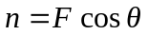; the vertical component of the applied force must be equal to the weight of the brush plus the friction force, so that 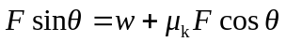, and
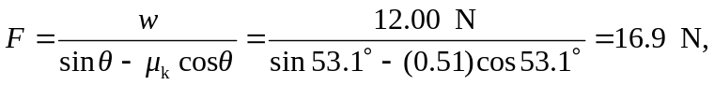
keeping an extra figure. b) .

